MINISTRY OF THE RUSSIAN FEDERATION FOR PUBLIC AND VOCATIONAL EDUCATION

State Educational Institution of Higher Professional Education

«TOMSK POLYTECHNIC UNIVERSITY»

Computer Graphics

" Model color space "

Perfomer:
Student of group 8V24 ___________ O.M.Teryokhina
(Date)
Tutor:
___________ A.U.Demin
(Date)

Tomsk – 2004

CONTENTS:

Preface............................................................................................................2
- Model color space RGB.........................................................................3
- Model color space CMY and CMYK.......................................................5
- Models color space HLS, HIS................................................................7
- Model color space CIE XYZ...................................................................10
- Models of television YUV, YQI...............................................................14
- Models color space HSV, HSB..............................................................16
- Mutations of model CIE XYZ
7.1 LUV..................................................................................................17
7.2 LAB..................................................................................................18
8. REFERENCES.................................................................................................. 21

Preface

Eye registers light waves. But this light, as we describe further, is the evaluated by brain set of impressions fabricated in receiving points of eyes. Eye forms impressions in its receiving points on the base of the light waves reaching eye from outside. These waves undergo transformation in receiving points into impressions. Such transformation is not the mutually one-valued function (as 1<->1) in mathematical meaning (which we will motivate further). It signifies so much, as the same any impression fabricated in eye can emerge in the result of different configurations of light waves. In such circumstances we must distinguish two sets for generality of consideration.

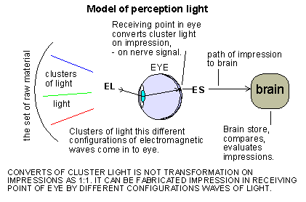

As the same impressions can emerge from different configurations of light waves, so identifying of notion of colour with one certain light wave is senseless. Person "sees" colours as a result of processing of clusters of light waves into impressions. Brain evaluates the result of transformation but light waves not. But on the other side, there is the developed and generally accepted terminology, for example concerning the colours measurements. So, what do these measurements concern?
All the seen electromagnetic waves plus all the subsets of such waves in the meaning of clusters of waves and also of different intensity, we will call the set of raw material.
By the composition of impressions we will understand the collection of all possible results of transformation of raw material elements by the receiving points in eye into proper signals for nerves of eyes.
Because transformations of elements EL (element of raw material) into elements ES (element collection of impressions) are not mutually one-valued, so, in order to say that there is suitability or relation between impressions and elements of raw material, you should associate ES impression with the sum sEL of elemets EL (in the meaning of sum of sets) of all the elements from set of raw material, which evoke the given impression.

In such circumstances, ES or sEL must be attributed to the terms of colour, depending on circumstances. What is about the question here? Namely, use of the words: colour in colloquial language, concerns calling of impression. But when we say for example about folding of colours, that's not yet the question of folding of colours, because it makes eye, but that's the question of folding of raw materials elements, we can effect it, at the very most, what eye makes. In the case, when we say about models of areas of colours, these objects want as if to describe the set of impressions, but really they describe the set of raw material. In the case when we say about colour measurements, these measurements concern raw materials elements, not measurements of impressions. So, when we will use the word "color", and when the situation will require it, when it will be important, then we will mark the set, of which is concerned - the set of raw material, or the set of impressions.

At the discussion of questions of colours we will be trying to use the terms applied by Authors (initiators) of the light theory. The names applied by them have character of the personal names, like the names of mountains and rivers, and the names of measuring units etc. It is possible, certainly, to substitute locally such names for other names of (national language), which are more friendly than the names originating from the language of Author, but they are not allowed to eliminate from onomastics when we are discussing of a given theory.

- Model color space RGB

Model RGB is one of the first practical models of area of colors and contains the recipe for creation of colors. This model has emerged in evident manner in the times of birth of television (1908 and the next years). This is the model resulting from the receiving specifities of eye and it is based on fact that the impressions of almost all the colors in eye can be evoked by mixing in the fixed propotions of three selected clusters of light of the properly chosen width of spectrum. Basing on this model the pictorial lamps - kinescopes work to nowadays. Despite it, that the same signal of color television is based on the completely different manner of coding of colors (there are several such manners for television).

Three of components (r, g, b) (r=Red, g=Green, b=Blue) is the identification of color in the model RGB. A single component is the number proportional for intensity of a cluster of waves corresponding with the given cluster. Simultaneous emitting three clusters representing components in proper propotions of energy can cause an impression corresponding almost white light - impression of the reception of emission approximate to the full spectrum of section of waves from 400nm to 700nm. However, simultaneous emitting such three clusters in differently selected proportions can evoke the emerging of impressions of other colors in eye.

Here it is a good moment to call your attention to a small detail. The white light consists of great and endless amounts of waves differing in frequency, and, in order to produce the impression of white light in eye, it is obvious that the mentioned clusters here can not be single monochromatic waves or clusters of such waves (such, for example, laser gives). It must be the clusters of light of chosen width of spectrum.

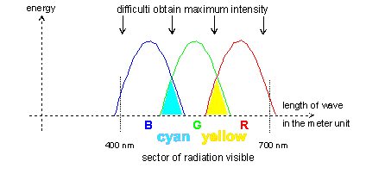

Model RGB has defects. Beyond the case of whiteness, the colors among B:G or G:R are only the approximations for full cyanogen or respectively - for full yellow color. But this model is satisfactory for eye of person. It is usually presented as a fragment of three-dimensional space enclosed in a cube of singular side - as on the illustration (exact to the permutation of co-ordinates).

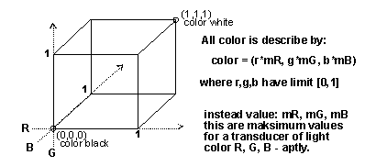

The point (0,0,0), that is the zero intensity of all components, answers a notion of black color. However, the point (1,1,1) represents whiteness by itself. The section (diagonal) from the point (0,0,0) to the point (1,1,1) represents the levels of greyness from blackness to whiteness by itself. The other points, generally a*(r,g,b), as vectors with start in the point (0,0,0) represent theoretically the different increase of color, it is said about the different intensity of color and certainly within the bounds of the singular cube (we write about the intensity of colors further on). Model RGB defines in the evident manner that what the intensity is but for the individual components R,G,B. Namely, the values of components RGB describe individually the intensity of the given basic color as a number of partition from 0 to 1 and do not subject this value to the two remaining components. It is said that the components RGB are orthogonal independent from each other. The value of components =0 means a zero of the intensity of basic color. The value =1 means a full highest intensity.

The point of form: (w,w,w), where w=max(r,g,b), marks by itself the level of whiteness, in which there are included all the components of the point (r,g,b), or more generally, all the possible elements of colors. However, the place k=min(r,g,b), that is the point (k,k,k), is considered as the minimal level of brightness. It is called a non-chromatic component. The point (k,k,k) is simultaneously such a place, from which "outstanding parts" of the components correspond to the color called a chromatic component, which is colloquially called by some people as an impression other than black and white one, or, as some prefer, "clean color".

- Model color space CMY and CMYK

The consideration with use of the model RGB are good for the appliances, which emit a light, but in the circumstances related to presentation of the picture on passive carriers (printing) direct use of the description of points from the model RGB is not possible. Person calls the colour of paint as he sees it. Surface of paint reflects the light from environment and this reflected light gives an impression called the colour of paint.
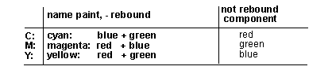

Difference between white light and NOT reflected light:
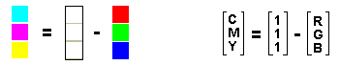

(c,m,y)=(1,1,1)-(r,g,b)

The components of color which have been emerged from such a difference are called CMY letters, because from the analysis in natural manner result basic colors and they are located on a axis of length of waves between basic colors from basic RGB model. Their proper names are: Cyan, Magenta and Yellow. Hence the co-ordinates are called CMY. Cyan color is situated somewhere between blue and green, color Magenta (violet, crimson) has some red and blue and Yellow (yellow) is situated between green and red.

Base colors fixed in that manner have theirs counterparts on surfaces of a cube in RGB space respectively: Cyan: (0,G,B,) Magenta: (R,0,B), and Yellow: (R,G,0). As we mentioned, color of whiteness is a conventional notion. From RGB model, the point of whiteness (R,G,B)=(1,1,1) transmits itself to point CMY=(0,0,0) with its all the conventionality, and this way it is the conventional white color. We may say that it is a color of a basis. Point RGB=(0,0,0) as a black color transmits itself to point CMY=(1,1,1). Such color can be black more or less at the very most, because it is practically impossible to fabricate a mixture for black color using three other colors from CMY set.This fact is often explained as a "dirtiness " of CMY components but it is not a truth in all respects. There is a situation that we need to prepare a mixture of three paints in amounts different from zero, and which will not reflect any color in fact. So, such mixture must achieve a border, that all colors, reflected by certain components of paint, must be damped (a bit absorbed or caught) by other components. So we receive a black color in theoretical border with accuracy to small part of paint. Hence there are difficulties with practical obtaining of black color.
Because of the same reasons as it is in RGB model, also in CMY model it is impossible to describe all colors. But in printing, especially for blackness and whiteness, describing them respectively as a more and less black and white is not acceptable. Thus, in CMY model there was added next component K - describing amount of fourth paint.

Black paint is fourth paint formally and white basis is a formal condition for CMY.

In this way we have a CMYK model.
The model does not say anything in evident manner about transparency of paints. In printing there are mostly used paints which reflect the color that we desire with the possible biggest ratio but smaller than 100%.
However, the paint should be transparent in the highest degree for colors not reflected. Generally the paint partially absorbs and partially misses these other colors. In this way thickness of a layer of the paint can adjust itself a little bit the amount of reflected light from whiteness of the basis and passing by the paint (twice).
There are different technologies depending on circumstances. Sometimes color is obtaining in way of paint mixing or putting coats of paint. Please, pay attention to that a "given paint" concerns single point of an image. And such procedure must be applied separately to each point of an image. For example we may here indicate an ordinary color printer which makes just such operations.

- Models color space HLS, HIS

The searching of new technologies for mathematical description of colors has been inspired particularly by industry. The models called HLS and CIE XYZ have emerged more or less parallelly, in years 1930, 1931 (next section deals with CIE model). You peek also to section: Transformation HLS and RGB or HSI and RGB.

In HLS, HSI models it was accepted that the color is possible to describe itself by means of a single representative of one monochromic wave of light Hue with the specification of Saturation measure for wave, and the specification of Lightness level or with the specification of Saturation measure and Intensity measure. The onomastics of models comes from the initials of terms of English language used for calling the elements of description. H: Hue: (indicates the frequency of wave of light), L: Lightness (average white light), S: Saturation, I: Intensity.

HLS, HSI and CIE models sprang after a period of quite significant achievements in the sphere of the light theory, approximately it is the period 1850-1930, more or less when television was just born. The first laboratory tests of the synthesis of picture (black and white) had been made in the first decade of the years of 1900, that is about 1908, in the laboratories of USA. The first public demonstration of the television pictures was in 1929, in USA too. The first tests of kinescopes in the form analogous to today's structure of kinescopes were just about in the years of 1930 in USA. However, the first regular tv program (black and white) is dated of 1936 in Great Britain.

In HLS and HSI models it is assumed that the elements of model are orthogonal, independently from each other, except Hue definiteness for the case S=0. One sould "look" at such elements as at "regulating knobs". Each of the elements can be changed from min to max and independently from each other. But is there a conformity for real values, for example of saturation or intensity, that is just another matter. Such elements reckon some propotion of value within the limits of that what is possible, what is reckoned by a state of other "regulating knobs". Such interpretation turns out to be very useful when we consider the transformation. But this interpretation means the dependence of real values, which such model describes. This is a contradiction of a certain kind with assumptions of the orthogonality of elements.
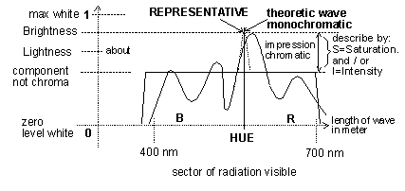

Lightness level defines the average level of light - this is the place between non-chromatic component and the level of Brightness light.

The wave of light representing color is the identifier of color. Sometimes there is used the term "dominating wave" coming from Ostwald's conception (dominant, purity, luminance).
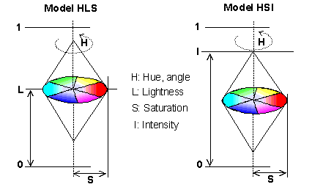

Both HLS and HSI models in the graphic form as a double cone represent dynamically the current values of components.

Hue component defines the frequency of the wave of light. The general assignation of the frequency of lighting waves results from division of the angle of 360 degrees into three parts of 120 degrees each (circle of Newton's colors). The angle of 0 or 360 degrees answers the center of red color. The angle of 120 degrees answers the center of green color. The angle of 240 degrees answers the center of blue color. Other intermediate colors for Hue component are properly linearly distributed. The value of Hue can be changed independently of other elements of a model. The change of the value of H changes the chromatic component, but in such a way that all other parameters, as saturation, intensity, levels of whiteness, do not undergo to the change. Hue component is indefinite when S=0, that is, when saturation equals zero.

L component (Lightness) in HLS represents itself the average light of color. In this model the value of L lacks for relationship in the meaning of equality with other parameters of color. It defines the relationship with the luminance according to inequality:

Lum(notchroma) <= Lightness <= Lum(color)

This light lies always somewhere inside among the above-mentioned values. The value of Lightness can be changed from 0 do 1.

Saturation component represents itself the saturation of color. The saturation of color, as we know, is the propotion of the chromatic element in the whole color, which is the part of it. The value of Saturation can be changed always from 0 to the value of 1.

Intensity component defines the intensity of the whole color and its value can be changed from 0 to 1 too.

Double model cone is attached to zero level by its bottom top in some presentations of HSI model. In such circumstances when the value of Saturation aims at zero, then the lump is transformed into the section from 0 to the value of Intensity. When the bottom top is not pinned on zero level, then the lump aims at the point on axis of Intensity of the value of Intensity when S aims at zero. In any case, the value of Intensity as the value remains the same.

The discussion on HSI model has been lasting for some time. From this discussion an algorithm of transformation of RGB model into HSI has been rised, more or less, in the following way:

I=(r+g+b)/3 and S=1-(3/(r+g+b))*min(r,g,b)

But, by accident the value Saturation has been subordinated quite evidently on the value Intensity, what is contradictory to assumption about the orthogonality of components of HSI model. And, besides, it is contradictory to situation for example for I=1. It appears that each color of the intensity 1 has to turn into white light in RGB model.

Used onomastics as Saturation, Intensity, Hue, just descended from different theoretical conceptions, has become an inspiration for the constructors of the first television receivers for common use, to color reception (1956 - USA, that is about 20 years after starting of the general public black and white television). At that time, the constructing of television receivers had been such that the ordinary users of television did not have yet experience of the adjustment of color, it was made what was known. In such circumstances, the regulating knobs named like as: Brightness, Saturation, or Hue, have been made in the television receivers. The regulating knobs named X,Y,Z certainly did not come into consideration. Hue regulator was very curious, it has been adjusting a section of the frequency of light waves for taste of the receiver, moving this section to left or right what gave the astonishing effects.

- Model color space CIE XYZ

There are several organizations in the world which work upon the mathematical instruments for the description of the visible light. There are for example (ANSI): "American National Standards Institute", (ISO): "International Standards Organization", (CIE): "Commission Internationale de l'Eclairage".
In 1931 CIE has presented and suggested a model of area for the description of colors in correspondence to the included waves creating the impression of seeing of colors. This model arranges certain sub-set of the elements of raw material, arranges the individual frequencies of waves for other elements of raw material, and fixes the mathematical dependences what is the form of arrangement too. It attributes the three of numbers (X, Y, Z) for the individual electromagnetic waves, but without the information about the intensity of a wave. It gives the possibility (gives algorithm) of construction of other elements of raw material through the folding of waves represented by the three (X, Y, Z), but also without the information about the intensity for the result of folding. However, if it is the question of description of the elements of raw material in consideration of the intensity of color, then these dependencies are related with the accepted (assumed) white light, about what in a moment.

Generally, for the fixed illuminant (it should be underlined: fixed illuminant) the points of surface X+Y+Z=1 are considered in the three-dimensional area, and all the points of this surface not necessarily must be used. The colors have theirs "symbols" as the points on the surface X+Y+Z=1. The color of whiteness has such a symbol too.
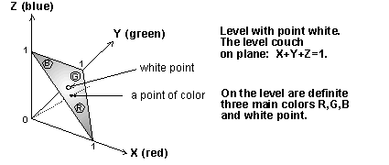
The defined surface includes the point of whiteness according to the fixed illuminant, and three more definitive settlements for the basic colors R,G,B are specified for this surface.

On so constructed area there have been fixed the places for the points corresponding colors: red, green, blue and whiteness. Namely, the people have been put as observers. These people had theirs task to make estimation in consideration of the maximum of impression with reference to three colors R, G, B. It has been produced sufficiently the narrow cluster of light. The color of the cluster had been under a change with the step of typically 5 manometers (later it was made with the step 1nm). Each step was estimated by observers as the estimation of three questions by turns: are there more or less color. And certainly these three questions concerned R, G and B. This way, there have been fixed three numbers (X, Y, Z), form of curves individually for X, Y, Z, as well as extremes and theirs surrounding. And these extremes, at this fixed white light, was placed on surface X+Y+Z=1 by leading the received estimations (X, Y, Z) to this surface. The received components of points have been divisible by the sum of components.

The extremes gave the highest values of the co-ordinates for the components (X, Y, Z). These highest values before leading them to the model surface can be found only in the tables distributed by CIE, they concern the statistic estimation of three colors by turns by the appointed group of people.

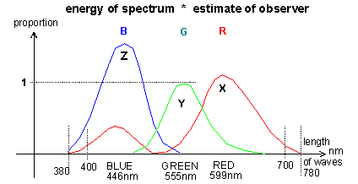

On the ground of such the based on authority data, it is possible to fix the extreme places exactly, as well as the places of the crossing of the individual courses on axis of the length of waves. The numbers given on the presented illustrations are taken from these data.

The disturbance in a region of the left of the side-space of blue color is, as we know, a specific circumstance of the structure of receptors R and B in eye (look chapter: Eye model).

There is such an unwritten convention that the capital letters X, Y, Z mean that the point (X,Y,Z) does not lie necessarily on surface X+Y+Z=1. On the other hand, the small letters x, y, z mean that the point (x,y,z) is placed on model surface, but it is not obligatory.

The whole course of estimations is presented mathematically by means of three functions as an integral from product (or simply sum of products).

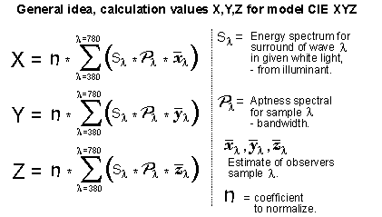

Energy of the spectrum of sample - times the estimation of impression, going over the increases of the length of waves on section from 380nm to 780nm (typical step is exactly 5nm). The estimation of impression is the conventional symbolic value given properly for the statistic result from the estimation of man. At the same time the value =1 of this estimation concerns the maximum place for the estimation of G color (green color). Such the conventional value of estimation was therefore accepted, because green color produces the biggest impression in eye (eye is most sensitive for this color). The extreme places are the places which correspond with R, G, B colors, properly X, Y, Z. Certainly, after coming down of the received points (X, Y, Z) to the model surface X+Y+Z=1, the values (x, y, z) do not reflect any more theirs highest values emerged at measurement.
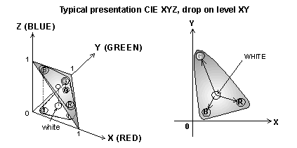
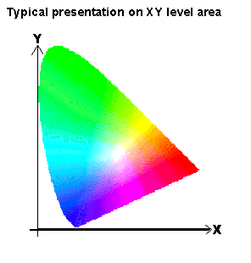
Bringing of the points (X, Y, Z) on the model surface is applied in very few cases. It is to be remembered that the point (X, Y, Z) can bear with itself the information about the intensity of color. When such point is brought on the model surface, then the information about the intensity disappears. Because it is not known what was the primary amount of the components.

In such situation you can consider the directions of vectors from (0, 0, 0) to (X, Y, Z) as color (we underline: the directions). The directions can be folded like the vectors are added. When we have two points: P1=(x1,y,1,z1) and P2=(x2,y,2,z2) on the surface X+Y+Z=1, then there are certainly the identities: x1+y1+z1=1 and x2+y2+z2=1. The amount P1+P2 gives by itself a vector. In order to fix the point of intersection of this vector with the surface X+Y+Z=1, you need to divide the resultant co-ordinates by 2, after performing of the amount of vectors, and the amount of the components will be =1. It means that we have: P3=(P1+P2)/2 is the point on the surface X+Y+Z=1. Generally, after performing of the amount of vectors, which not necessarily do not have to come from this surface (they can lie under or above this surface), for such point P3 you divide yet its components by the amount of all its components, certainly if there is such need.

From its assumption the notion of whiteness is the light which includes all elements of raw material. The folding of only colors Rxyz+Gxyz+Bxyz from the model surface XYZ can not give the direction for the point of whiteness. This fact is just a reason that the mathematically fixed direction Rxyz+Gxyz+Bxyz does not give the point of whiteness difined for the model. Because if it was, then the definition of it would be purposeless. There are defined four points for the model XYZ: Rxyz,Gxyz,Bxyz and the point of whiteness.

The points on the model surface give us the possibility of folding of colors, but with discretion if it is the question of the interpretation of result, it depends on that what such result is needed for. Namely, the points between R and B can give a result of colors from the region of purple. The purple lacks its single representative among the electromagnetic waves. And if we need to fix the element of raw material, one should be wise when such element is to be the single electromagnetic wave. When the result can be the sub-set of raw material, we don't have to care for it.

As we have already noticed it, the points on the model surface do not give any information about the intensity or saturation of color, these are the model colors. The useful information is given by the component Y from the point of white color. Dividing of the components of this point by the value of the component Y of the same point gives the point: (Wx,1,Wz) and this point in the model XYZ corresponds with the lumination of light Brightness, that is the lumination of the model whiteness. It fixes the propotions according to the values of the components Wx and Wz for red and blue in white light proper for the accepted illuminant. And just such proportions you can attribute to a device producing colors. In such way you can create an area of colors from the model CIE XYZ.

- Models of television YUV, YQI

After the first show of black and white television (1926), there has been emerged the strong impulse to construct systems of color television. As we have mentioned, the first public demonstration of color television took place in 1929. But the first general television for color reception took place only in 1956 in USA. This date is therefore assumed that it is the date of starting of the first transmitter for the public color television.

Television, which was just sprang out, has realized the reasoning in the construction of the models of area colors. Practically, there are existing two models very similar to each other. Differences result from different technical decisions of the independent from one another constructors and designers of television signal. Practically, two kinds of the models of area colors for television signal have been become widespread in the world.

Television is based on model YUV in Europe, and there is yet a division within this model, in consideration of the manner of coding of the components of model. This manner of coding is called by the systems of names: PAL and SECAM.

Symbolic letters in the name of model have definitions only within these models. For example, you should not join the symbol Y with the same symbols in other models.
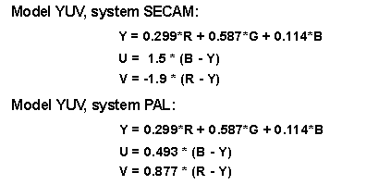
There is spread on American continent (USA, Canada ) and in Southeastern Asia (Japan) the system of transmitting of color television called NTSC. The model of description of colors in this system is called YQI.

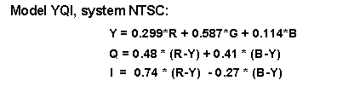

In all these models Luminance is the same. This fact should allow it for each televisor to have the possibility of picture reproducing, at least black and white. In fact, however you can meet situations that it is not so. It results from the fact of dissimilarity of manner of final construction of television signal for emitting by transmitter. For example, in France there is existing french Secam which differs in that, among other things, that the luminance is sent as a denied value. And such detail makes already possible for reception of pictures by an unadapted televisor.

The component Y called luminance, practically, at a given moment for the entirely multicolored picture fixes a place, somewhere between a minimum and a maximum. Fixing R, G and B, and individual use of them lowers or increases individually the emission for proper three colors in kinescope. We desire to call your attention here, that the component Y corresponds more or less the light Lightness defined by CIE organization, but according to values is different from definitions coming from this organization. For practicians this is the black and white content of the entirely colored picture.

- Models color space HSV, HSB

One more proposal of the model of colors' description, suggested by Alvey Ray Smith, appeared in 1978. This model resembles a little HLS or HSI. This model refers to the manner of vision of person, where any colors are the light coming from illumination. This model is often defined as a model of colors for artists. All colors descend from the concrete light of whiteness. The model has not rather the practical use, except for creators artists. (You peek also to section: Transformation HSV,HSB and RGB).

The symbols in the name of model are the first letters of English names for the components of the description of color. The model is considered as a cone of round base. The dimensions of cone are described by the component S (Saturation) and the component V (Value) which is an equivalent of the name B (Brightness).

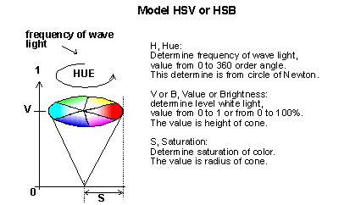

The solid figure of cone is considered for data S, V. For other S, V the cone will have other proportions of shape. The general arrangement of the frequencies of light waves is analogous as in models HLS or HSI, that is: the centre of red color corresponds with the angle of 0 degrees or 360 degrees. The centre of green color corresponds with the angle of 240 degrees. Other intermediate colors for the component Hue are properly linearly put.

The component Value or Brightness represents by itself a level of whiteness, from which the color takes its origin. The parameter S=Saturation concerns the propotion of the chromatic element in color as a whole. In order to fix the intensity of the chromatic element you need therefore to fix the value: S*V. Because the chromatic element is always highest in whiteness, from which the color takes its origin. From the feature of the highest chromatic element results that the saturation and the intensity of this element are then of the same value. Therefore the propotion of the intensity of the chromatic element in color is expressed by S in limits of that what is possible, so the chromatic element, which is possible, is just: =S*V.

In border, the value Saturation=0 means that the saturation of color totals zero and then Hue is not definite, and then we have a given level of whiteness proper for Value (or Brightness), and the cone turns into a section.

- Mutations of model CIE XYZ

7.1 LUV

After some time from announcement of CIE XYZ in 1931, and after acquiring different experience, two changes of the model CIE appeared. There were different needs. From one side, the television for transmitting of pictures in color was just born, and from other side, there were appeared other needs, as for example the registration of pictures for television, in printing industry, in photographic industry.

Organization CIE, independently of other organizations as for example OIRT normalizing the television signal, continued the work at a development of its model CIE XYZ. The criticism of this model has contributed, among other things, to the announcement of model XYZ variants by CIE. The criticism has lied in that the co-ordinates in XYZ "thicken" much the regions of the passages among basic colors, that is the passages of yellow, cyan, magenta colors cause that all presentations on projections of the surface XYZ on the surface XY have disproportionate regions of, for example, green color in comparison with other colors, and cause the necessity of overcoming many non-linearities in peripheries and regulators in all technical devices which with purpose would imitate behaviours according to three co-ordinates from area XYZ. And besides, the perception of the changes of luminance of white light by means of eye departs far away from the linear perception.

In more or less such circumstances they partially returned to the conceptions, developing since 1931, and color television - partially already working - has become a kind of suggestive pattern. Namely, there have emerged the models also based on three components. One of these components is the level of whiteness defined as the luminance of whitenees in the notion of light Ligthness and non-linearity related to this notion. Two remaining components describe just two real colors. Very similarly as in the television signal. As organization CIE announced its new conceptions when color television had been already worked, it is hard to say that the transmission of signals of color television is based on CIE's works. There is rather contrary as far as new conceptions are concerned.

A model called LUV (sometimes determined as L*u*v*) is one of these first following new CIE models. It was formally announced in 1960. It is formulated by means of mathematical dependences with reference to CIE XYZ. L = light Lightness. However, parameters U and V are related to the mentioned below dependences (attention: symbols U, V here mean a different thing as opposed to television models, you should not identify these symbols of these two different models). Preliminary dependence:
However, these preliminary dependences used for definition of a model still caused big non-linearities of U and V parameters' changes. In 1976 has emerged its corrected a bit successor, and there was announced one more model called LAB (sometimes designated L*a*b*). The new model LUV has only one corrected factor, and other parameters are the same of preliminary dependency:

7.2 LAB

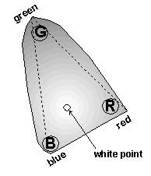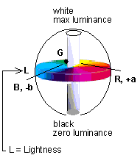

The components a and b represent two differences as in the definition below. The model CIE LAB refers a little to the models of colors expressed by the Newton's circle of colors.
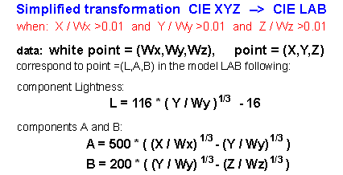

Generally values of the components LAB are defined in the following way:

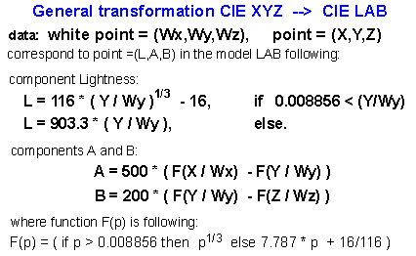

The values of the co-ordinates of the point of whiteness are constant, approximately equal: (Wx+Wy+Wz)/3. In such approximation the component A amounts about c1*(X-Y), similary the valuation for the component B can be defined as: c2*(Y-Z). On the base of such valuation you can just draw graphic representations.
Foot-note:
In order to take advantage of the model, it must be defined an area of colors. Only the points on the model surface: X+Y+Z=1, as we know, do not make an area of colors. So, the transformation of an area of colors, for example of RGB into CIELAB, must be mostly made indirectly. At first, RGB into CIE XYZ, and then the received points into CIELAB by means of the defined dependences. This way, we will receive an equivalent of CIELAB for devices of RGB type. We are talking about it, because the point (Wx,Wy,Wz) is not a point for which there should be the identity: Wx+Wy+Wz=1. This is the point of Your area, where the intensity and the saturation of colors is definite. The same notices concern the model LUV, too.

REFERENCES:

- www.semmix.pl/color Autor Tomasz Kozlowski

- http://www.color.org/

- http://www.digitalcolour.org/

